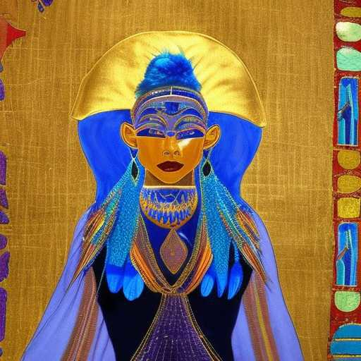
SIRIUS MEETS ARCTURUS

I flew to Hathor on a magic carpet
A woman draped in sparkling, effervescent strands of royal blue, turquoise and gold

Ma'at cusped by hearts in feathers
The Shekinah bathed me in ashing purple glories

My Father's House was eternal light and She was that very real sum of all illusions

Sirius meets Arcturus

